

Creational Patterns

## Factory Method (FM)



Creational Patterns

* Abstract Factory (AF)
* Singleton (SI)
* Prototype (PR)
* Builder (BU)
* Intent:



Factory Method (FM)

### Define an interface for creating an object, but let subclasses decide which class to instantiate.

* + Factory Method lets a class defer instantiation to subclasses.
* Also Known As
  + Virtual Constructor
* Consider a framework for applications that can present multiple documents to the user.



FM Motivation (1)

* To create a drawing application, for example, we define the classes DrawingApplication and DrawingDocument.
* The Application class is responsible for managing Documents
* the Application class can't predict the subclass of Document to instantiate
* Application subclasses redefine an abstract CreateDocument operation on Application to return the appropriate Document subclass.



FM Motivation (2)

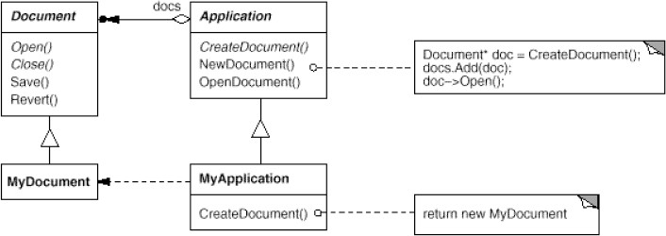

### Use a FM when:



FM Applicability

* + a class can't anticipate the class of objects it must create.
  + a class wants its subclasses to specify the objects it creates.
  + classes delegate responsibility to one of several helper subclasses, and you want to localize the knowledge of which helper subclass is the delegate.



FM Structure

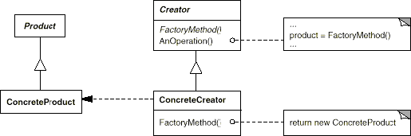

### Product (Document)



FM Participants

* + the interface of objects the factory method creates.

### ConcreteProduct (MyDocument)

* + implements the Product interface.

### Creator (Application)

* + declares the factory method (returns a Product).
  + may define a default implementation of the FM
  + may call the factory method to create a Product

### ConcreteCreator (MyApplication)

* + overrides the factory method to return an instance of a ConcreteProduct.

## Creator relies on its subclasses to define the factory method



FM Collaboration

so that it returns an instance of the appropriate ConcreteProduct.

### FM eliminate the need to bind application- specific classes into your code.



FM Consequences(1)

* + The code only deals with the Product interface

### Clients might have to subclass Creator just to create a particular ConcreteProduct object.

* + is fine when the client has to subclass the Creator class anyway!
  + …otherwise is a drawback (the hierarchy can explode)

■ FM

■ Provides hooks for subclasses.

■ Creating objects inside a class with a FM is always more flexible than creating an object directly.

■ FM gives subclasses a hook for providing an extended version of an object.

■ Connects parallel class hierarchies.

■ Parallel class hierarchies result when a class delegates some of its responsibilities to a separate class.



FM Consequences(2)

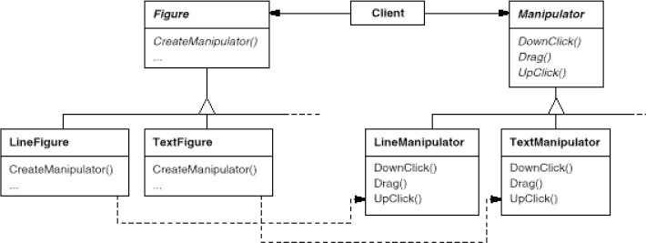

### Two possibilities:



FM Implementation(1)

* + Creator is an abstract class and does not provide an implementation for the FMs it provides
  + Creator is a concrete class and provides a default implementation for the FMs it provides

### Parameterized factory methods.

* + lets the factory method create *multiple* kinds of products.
  + The factory method takes a parameter that identifies the kind of object to create.
  + May require downcasting

## Naming Conventions

■ It's good practice to use naming

conventions that make it clear you're using factory methods.

■ Using templates to avoid subclassing.



FM Implementation(2)

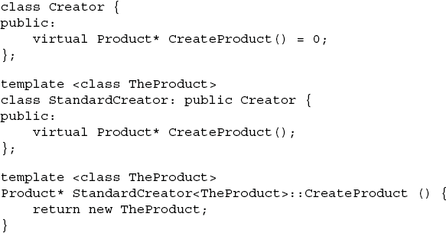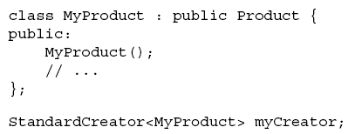

Building a Maze for a game

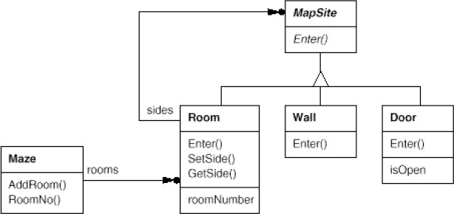



Sample Code

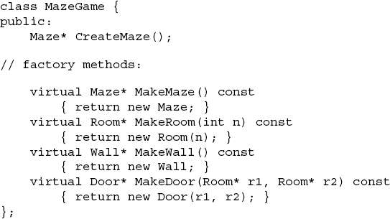

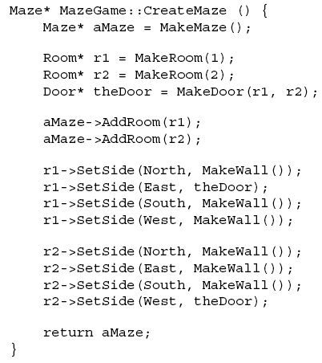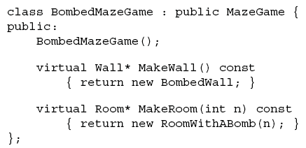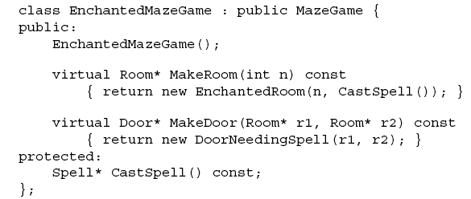

FM Known uses



and Related Patterns

* Known Uses

### Can be used in Abstract Factory

* + ….many softwares
* Related Patterns
  + Abstract Factory
  + Template Methods
  + Prototypes
* Intent



Abstract Factory (AF)

* + Provide an interface for creating families of related or dependent objects without specifying theirconcrete classes.
* Also Known As
  + Kit
* Consider a user interface toolkit that supports multiple look-and-feel standards, such as Motif and Presentation Manager.



AF Motivation (1)

* Different look-and-feels define different appearances and behaviors for user interface "widgets" like scroll bars, windows, and buttons.
* To be portable across look-and-feel standards, an application should not hard- code its widgets for a particular look and feel.



AF Motivation (2)

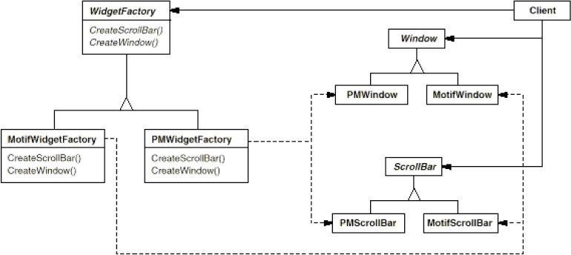

* Use the AF when:



AF Applicability

* + a system should be independent of how its products are created, composed, and represented.
  + a system should be configured with one of multiple families of products.
  + a family of related product objects is designed to be used together, and you need to enforce this constraint.
  + you want to provide a class library of products, and you want to reveal just their interfaces, not their implementations.



AF Structure

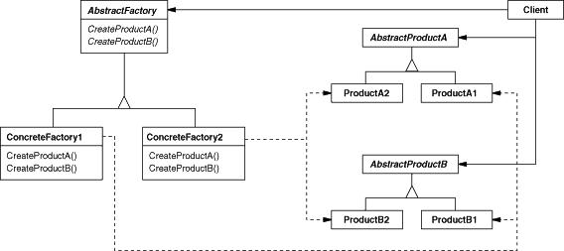

* AbstractFactory (WidgetFactory)



AF Participants

* + declares an interface for creating abstract products.
* ConcreteFactory (MotifWidgetFactory, …)
  + implements the operations creating concrete products
* AbstractProduct (Window, ScrollBar)
  + declares an interface for a type of product object.
* ConcreteProduct (MotifWindow, …)
  + defines a product object to be created by the AF
  + implements the AbstractProduct interface.

### Client

* + uses only interfaces declared by AF and Abs. Prod.

## A single instance of a ConcreteFactory class is created at run-time.



AF Collaborations

### This concrete factory creates product objects having a particular implementation.

* + To create different product objects, clients should use a different concrete factory.
* AbstractFactory defers creation of product objects to its ConcreteFactory subclass.
* It isolates concrete classes.



AF Consequences (1)

* + The Abstract Factory pattern helps you control the classes of objects
  + Clients manipulate instances through their abstract interfaces.
  + Product class names do not appear in client code.

### It makes exchanging product families easy.

* + The class of a concrete factory appears only once in an application.
    - This makes it easy to change the concrete factory an application uses.
    - It can use different product configurations simply by changing the concrete factory.

### It promotes consistency among products.



AF Consequences (2)

* + an application use objects from only one family at a time.

### Supporting new kinds of products is difficult.

* + Extending abstract factories to produce new kinds of Products isn't easy.
  + Supporting new kinds of products requires extending the factory interface
    - involves changing the AF class and all of its subclasses
    - This can be (partially) solved (see implementation)

### Factories as singletons.



AF implementation (1)

* + An application typically needs only one instance of a ConcreteFactory (Singleton).

### Creating the products.

* + AF only declares an interface for creating products.
  + It's up to ConcreteFactory subclasses to actually create them.
  + Implement AF by using Factory Method
  + Implement AF by using Prototype

### Defining extensible factories.



AF implementation (2)

* + AF usually defines a different operation for each kind of product
  + A more flexible design is to add a parameter to operations that create objects.
  + easier to use in a dynamically typed language like Smalltalk than in C++.
  + (see FM implementation)



AF Sample Code

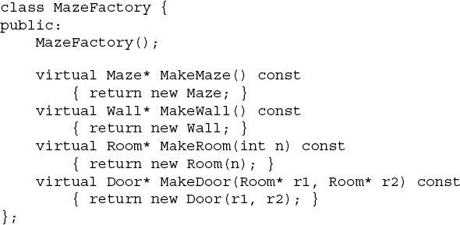

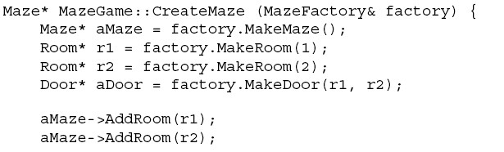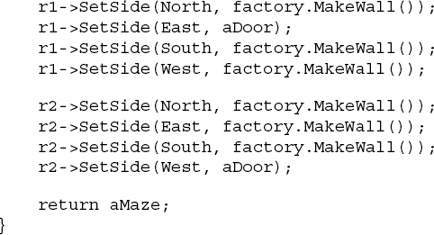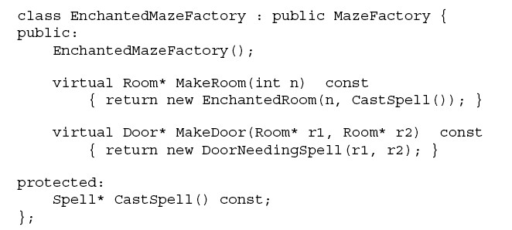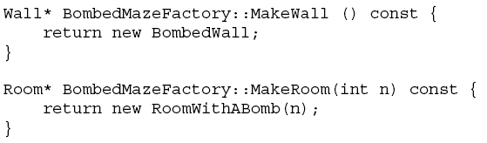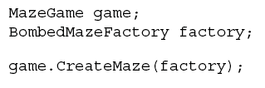

# AF Known Uses



and Related Patterns

## Known Uses

### …many applications

* Related Patters
  + Factory Mathod
  + Singleton
  + Prototype
* Intent



Singleton (SI)

* + Ensure a class only has one instance, and provide a global point of access to it.

### Motivation

* + If is needed to have exactly one instance of a class.
  + A global variable makes an object accessible,
    - but it doesn't keep you from instantiating multiple objects.
  + Make the class itself responsible of its sole instance.
    - The class can ensure that no other instance can be created
      * by intercepting requests to create new objects,
    - …and it can provide a way to access the instance.

### Use the Singleton pattern when



SI Applicability

* + there must be exactly one instance of a class,
  + …and it must be accessible to clients from a wellknown access point.
  + when the sole instance should be extensible by subclassing,
  + …and clients should be able to use an extended instance without modifying their code.



SI Structure

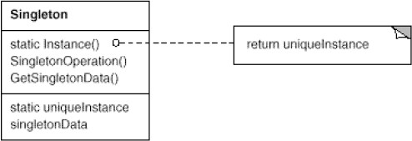

# SI Participants



and Collaborations

### Participants

* + Singleton
    - defines an Instance operation that lets clients access its unique instance.
    - Instance is a class operation (e.g. static member)
  + may be responsible for creating its own unique instance.

### Collaborations

* + Clients access a Singleton instance solely through Singleton's Instance operation.

### Controlled access to sole instance.



SI Consequences

* + strict control over how and when the client access.

### Reduced name space.

* + No name space-pollution by global variables

### Permits refinement of operations and representation.

* + The Singleton class may be subclassed
  + Use the instance of the class you need at run-time.

### Permits a variable number of instances.

* More flexible than class operations.
  + static member functions in C++ are never virtual

### Ensuring a unique instance.



SI Implementation

* + Hide the operation that creates the instance behind a class operation

(private constructor + static member)

### Subclassing the singleton class

* + The variable that refers to the singleton instance must get initialized with an instance of the subclass.
  + May be flexible to use a registry of singletons.

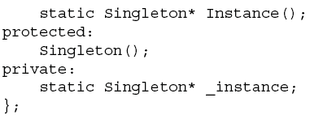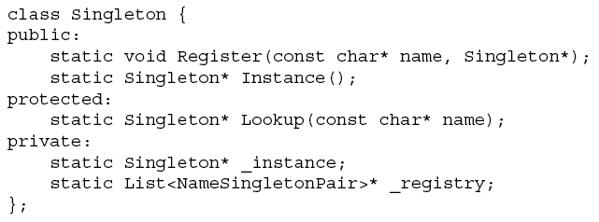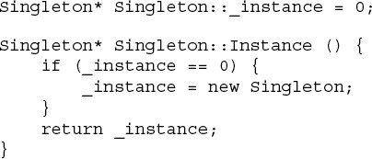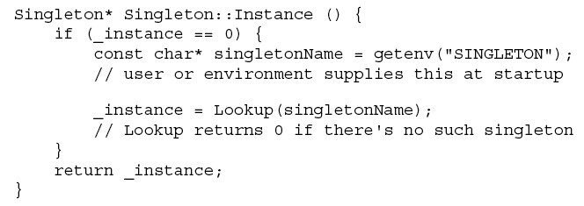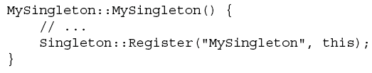

SI Sample Code

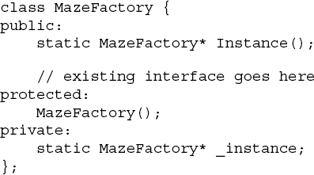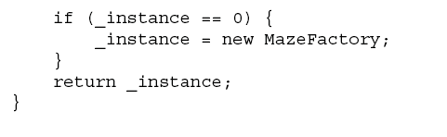



# SI Known Uses



and Related Patterns

## Known Uses

### …many applications

* Related Patterns
  + Abstract Factory
  + Builder
  + Prototype
* Intent



Prototype (PR)

* + Specify the kinds of objects to create using a prototypical instance, and create new objects by copying (cloning) this prototype.
* Motivation
  + Build an editor for music scores
    - by customizing a general framework
    - Scores are created by adding new objects that represent notes, rests, and staves from a palette
    - Sublcassing from an abstract Graphic class
      * produce lots of subclasses that differ only in the kind of music object they instantiate.



PR Motivation (continued)

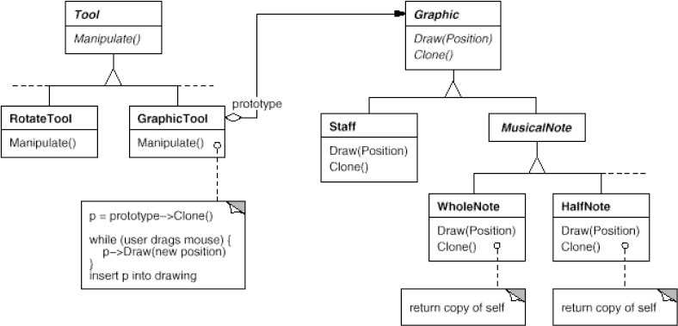

…make GraphicTool create a new Graphic by cloning an instance of a Graphic subclass (the prototype!).

* Use the PR when



PR Applicability

## a system should be independent of how its products are created, composed, and represented;

* + the classes to instantiate are specified at run-time
  + Parallels AF hierarchy may be very big
  + instances have one of only a few different combinations of state.



PR Structure

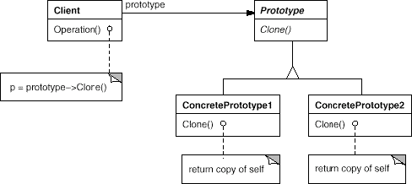

PR Participants



and Collaborations

### Participants

* + Prototype (Graphic)
    - declares an interface for cloning itself.
  + ConcretePrototype (Staff, WholeNote, HalfNote)
    - implements an operation for cloning itself.
  + Client (GraphicTool)
    - creates a new object by asking a prototype to clone itself.

### Collaborations

* + A client asks a prototype to clone itself.

### PR similar to AF and BU it:



PR Consequences (1)

* + hides the concrete product classes from the client
  + lets a client work with application-specific classes without modification.

### Adding and removing products at run-time.

* + a bit more flexible than other creational patterns, because a client can install and remove prototypes at run-time.

### Specifying new objects by varying values.

* + PR lets users define new "classes" without programming.

### Reduced subclassing.



PR Consequences (2)

* + FM often produces a hierarchy of Creator classes that parallels the product class hierarchy.
  + PR lets you clone a prototype instead of asking a factory method to make a new object.
    - NO Creator class hierarchy at all.

### Configuring an application with classes dynamically.

* + The Prototype pattern is the key to exploiting facilities like Java reflection in a language like C+

+.

### Particularly useful with static languages (C++)



PR Implementation

* + where classes are not objects, and little or no type information is available at run-time.

### Implementation issues:

* + Using a prototype manager.
    - When the number of prototypes in a system isn't fixed keep a registry of available prototypes.
  + Implementing the Clone operation.
    - It's particularly tricky when object structures contain circular references.
  + Initializing clones
    - If clients want to initialize the internal state
      * Introduce an Initialize(…) operation.



PR Sample Code

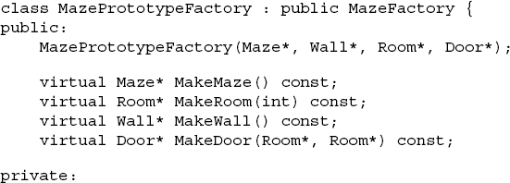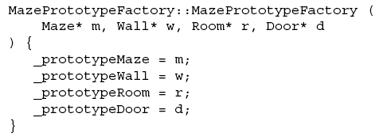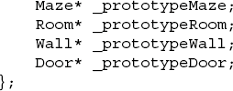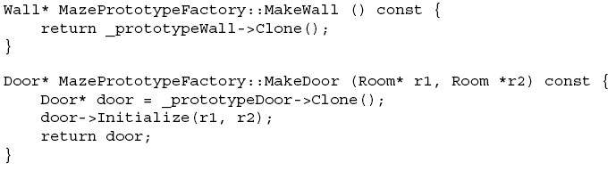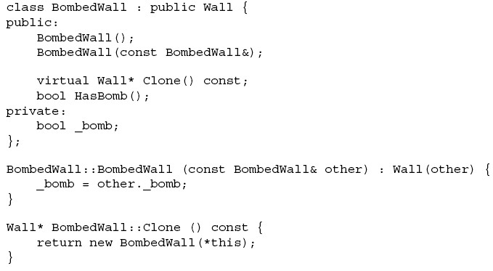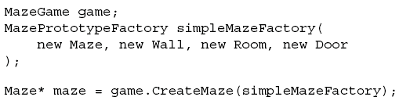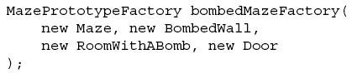

# PR Known Uses



and Related Patterns

## Known Uses

### …many applications

* Related Patterns
  + Abstract Factory
  + Composite
  + Decorator
* Intent



Builder (BU)

* + Separate the construction of a complex object from its representation so that the same construction process can create different representations.

### Motivation

* + A reader for the RTF (Rich Text Format) format
    - should be able to convert RTF to many text formats.
      * into plain ASCII text
      * or into a text widget that can be edited interactively.
    - It should be easy to add a new conversion without modifying the reader.



BU Motivation (continued)

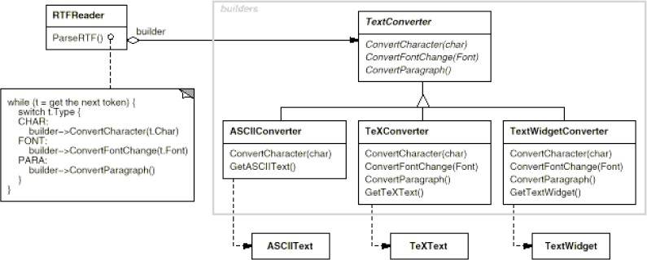

## Use the Builder pattern when:



BU Applicabiliy

### the algorithm for creating a complex object should be independent of the parts that make up the object and how they're assembled.

* + the construction process must allow different representations for the object that's constructed.



BU Structure

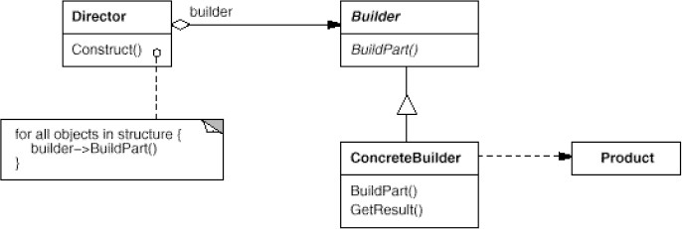

* Builder (TextConverter)



BU Participants

* + abstract interface for creating parts of a Product

### ConcreteBuilder (ASCIIConverter, …)

* + constructs and assembles parts of the product by implementing the Builder interface.
  + provides an interface for retrieving the product (e.g., GetASCIIText, GetTextWidget).

### Director (RTFReader)

* + constructs an object using the Builder interface.

### Product (ASCIIText, TeXText, TextWidget)

* + represents the complex object under construction.
  + includes classes that define the constituent parts

■ The client creates the Director object and

configures it with the desired Builder object.

■ Director notifies the builder whenever a part of the product should be built.

■ Builder handles requests from the director and adds parts to the product.

■ The client retrieves the product from the builder.



BU Collaborations

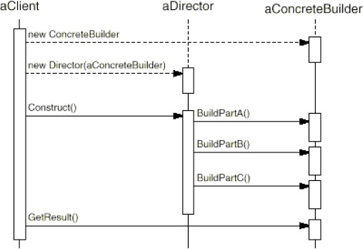

### It lets you vary a product's internal representation.



BU Consequences (1)

* + The Builder object provides the director with an abstract interface for constructing the product.
  + The interface lets the builder hide the representation and internal structure of the product.
  + It also hides how the product gets assembled.

### It isolates code for construction and representation.



BU Consequences (2)

* + BU improves modularity by encapsulating the way a complex object is constructed and represented.
  + Clients needn't know anything about the product's internal structure

### It gives you finer control over the construction process.

* + The product is built step by step under the director's control.
  + Only when the product is finished does the director retrieve it from the builder.

## An abstract Builder class that defines an operation for each component that a director may ask it to create.



BU Implementation (1)

* The operations do nothing by default.
* A ConcreteBuilder class overrides operations for components it's interested in creating.

### Assembly and construction interface.



BU Implementation (2)

* + Builders construct their products step-by-step
  + The BU interface allows the construction of products for all kinds of concrete builders.

### Why no abstract class for products?

* + The products differ so greatly in their representation

(e.g. ASCIIText and TextWidget differs)

### Empty methods as default in Builder.

* + Virtual member functions have empty methods letting clients override only the operations they're interested in.



BU Sample Code

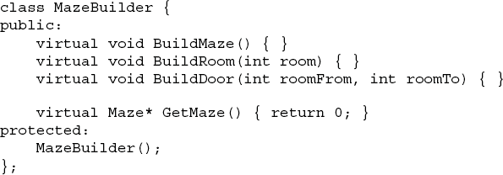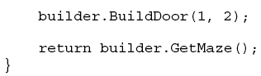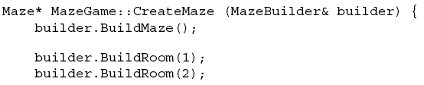

# BU Known Uses



and Related Patterns

## Known Uses

### …many applications

* Related Patterns
  + Abstract Factory
  + Composite
* Two common ways to parameterize a system by the classes of objects it creates:



Discussion (1)

* + To subclass the class that creates the objects

(Factory Method)

* + to parameterize a system relying on object composition

(Abstract Factory, Builder, Prototype)

* The main drawback of FM is that it can require creating a new subclass just to change the class of the product.



Discussion (2)

* + Such changes can cascade.

### The “composition-based” pattern

* + Involve creating a new "factory object" whose responsibility is to create product objects.
    - **Abstract Factory** has the factory object producing objects of several classes.
    - **Builder** has the factory object building a complex product incrementally using a complex protocol.
    - **Prototype** has the factory object (the prototype itself) building a product by copying a prototype object.